Better Internal and External Protection from Bacteria on ThePureBag™ Yoga Bag Compared with Cotton Yoga Bag Used in a Gym and Yoga Studio Setting After Two Days
Stephanie Schallenhammer, Villanova University Graduate Student October 5, 2017

OBJECTIVE – Current yoga bags do not provide protection from various bacteria, fungus, mold and mildew when used in a public setting such as a gym or studio. We compared the efficacy of protection both inside and outside of ThePureBag™ (TPB) yoga bag and a cotton yoga bag that were equally exposed to normal use in a gym/studio setting for two days.
RESEARCH DESIGN AND METHODS – There were two (2) bags utilized for this study – ThePureBag™ yoga bag and a cotton yoga bag. Both were new and never used prior to the two days of exposure to a gym/studio environment. For external exposure, both bags were placed next to each other on the studio/gym floor, the lobby floor and the bathroom floor for a total time of 2 hours each. For the inside exposure, a used yoga mat and a used towel were cut down the middle length-wise and each half was placed in each bag. The study evaluated both the inside and outside surfaces of both bags at three time points over the course of a 3-day period. The inside and outside surfaces of both bags were swabbed (for an equal amount of time) with sterile swabs and swiped in petri dishes for culture assessments. In addition, a petri dish was placed untouched inside each bag and then cultured and evaluated. These bags remained closed for the duration of bacteria growth each day and were only opened for photo collecting.
RESULTS – ThePureBag™ yoga bag cultures showed no viable bacterial growth for the Day 1, Day 2 and Day 3 evaluations for both the inside and outside surfaces. The few random colonies that appeared were possibly due to the handling of the petri dish upon photo acquisition. However, the cotton yoga bag showed significant growth of visible bacteria colonies on the outside at the Day 1, Day 2 and Day 3 days and growth of visible bacteria colonies on the inside at the Day 1, Day 2 and Day 3 observations.

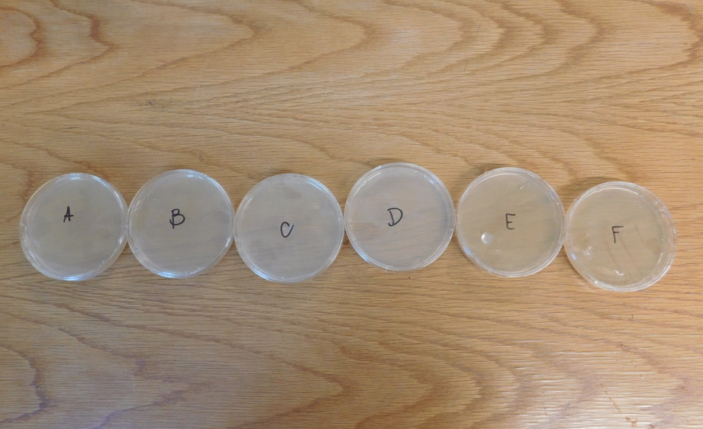
Figure 1. All petri dishes prior to swabbing.

Figure 2. Day 1 of bacteria growth. A.) The petri dish left inside the cotton yoga bag; B.) The petri dish that was swabbed inside the cotton bag; C.) The petri dish that was swabbed outside the cotton yoga bag.
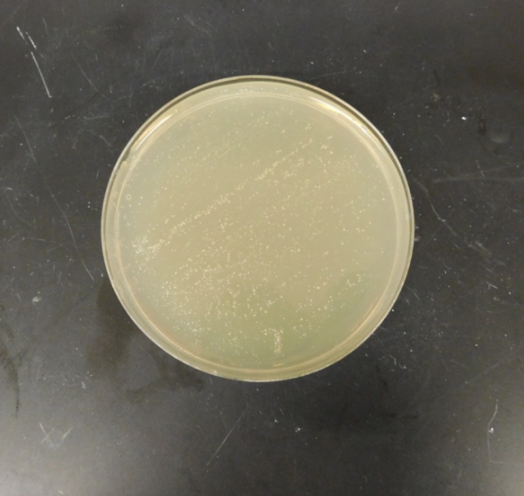
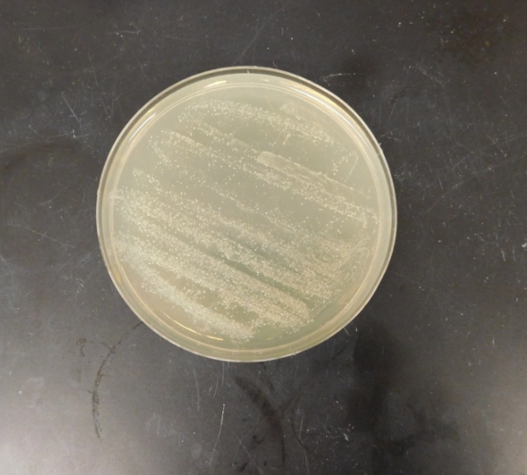
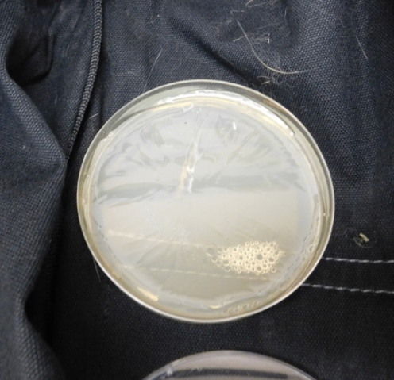
A.) B.) C.)

Figure 3. Day 1 of bacteria growth. A.) The petri dish left inside TPB; B.) The petri dish that was swabbed inside TPB; C.) The petri dish that was swabbed outside of TPB.
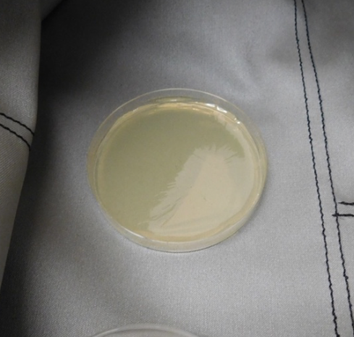
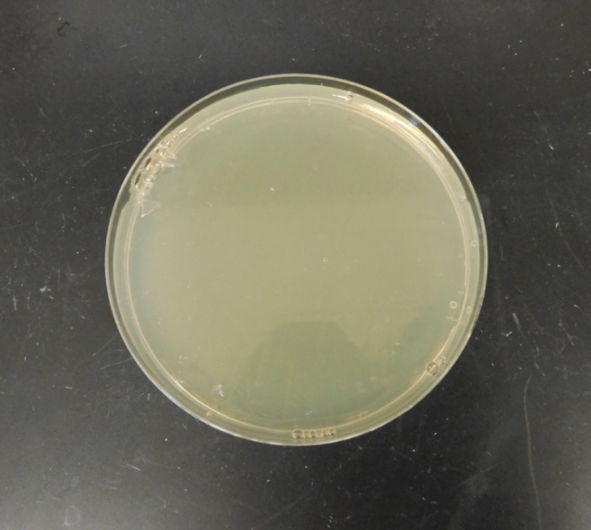
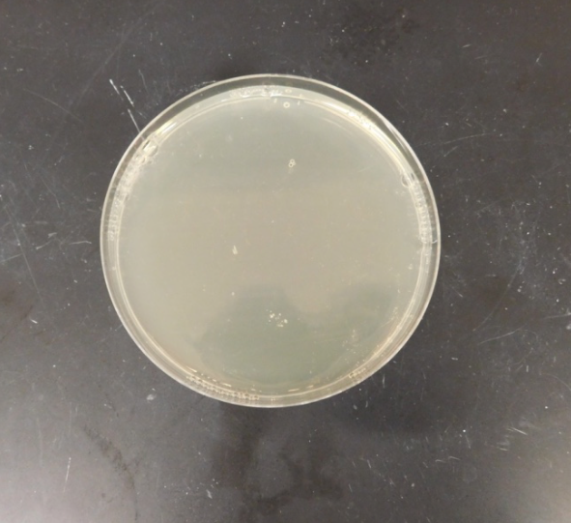
A.) B.) C.)

Figure 4. Day 2 of bacteria growth. A.) The petri dish left inside the cotton yoga bag; B.) The petri dish that was swabbed inside the cotton bag; C.) The petri dish that was swabbed outside the cotton yoga bag.
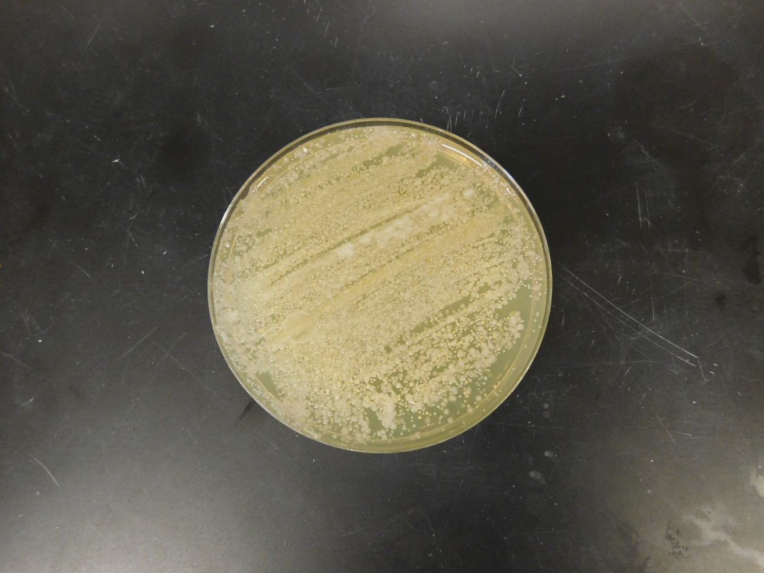
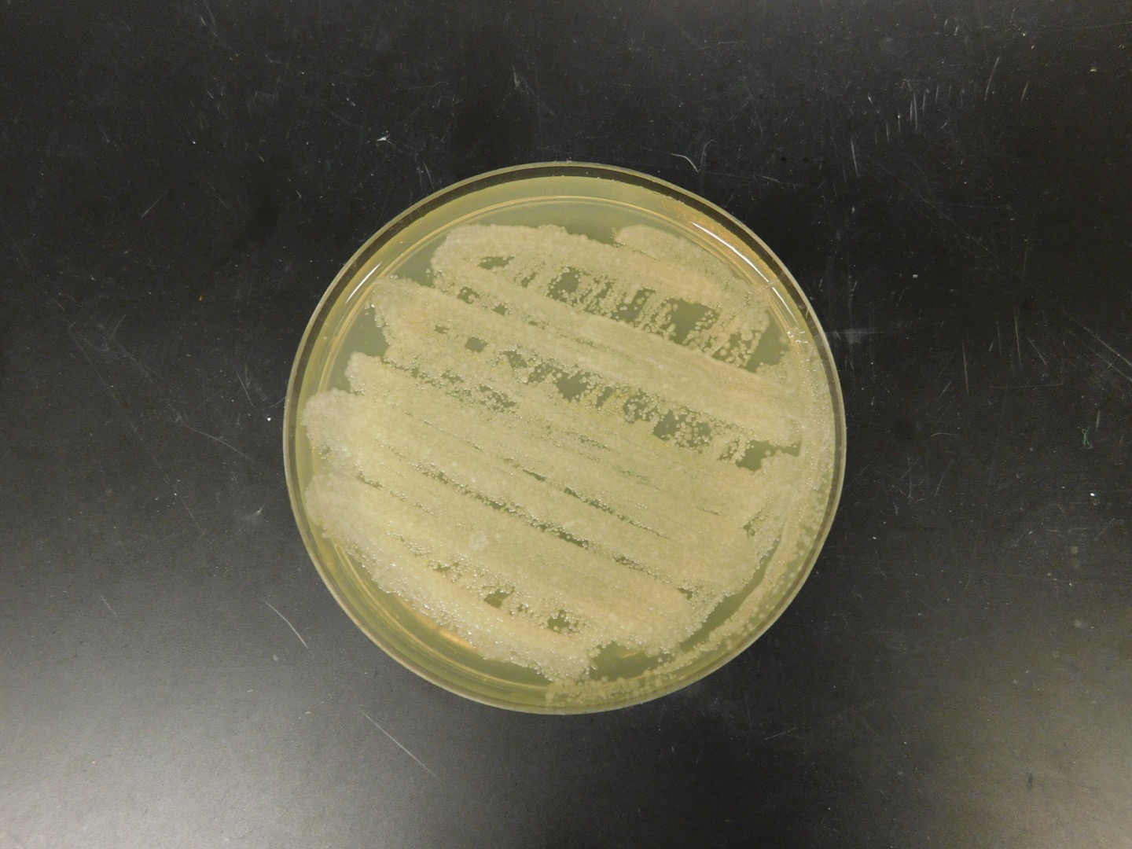
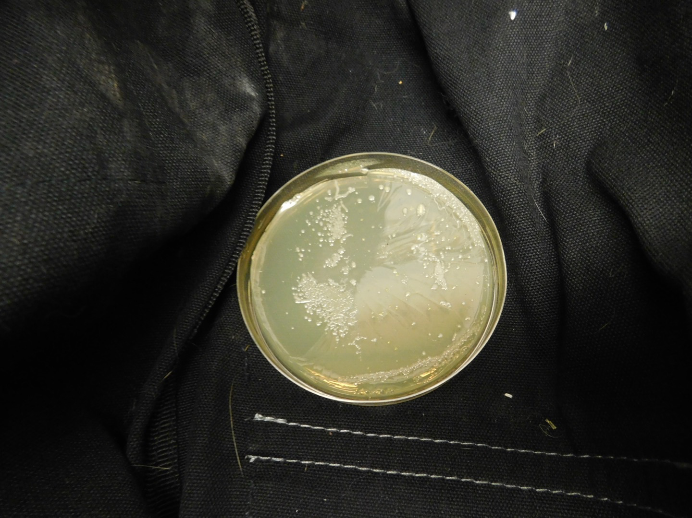
A.) B.) C.

Figure 5. Day 2 of bacteria growth. A.) The petri dish left inside TPB; B.) The petri dish that was swabbed inside TPB; C.) The petri dish that was swabbed outside of TPB.
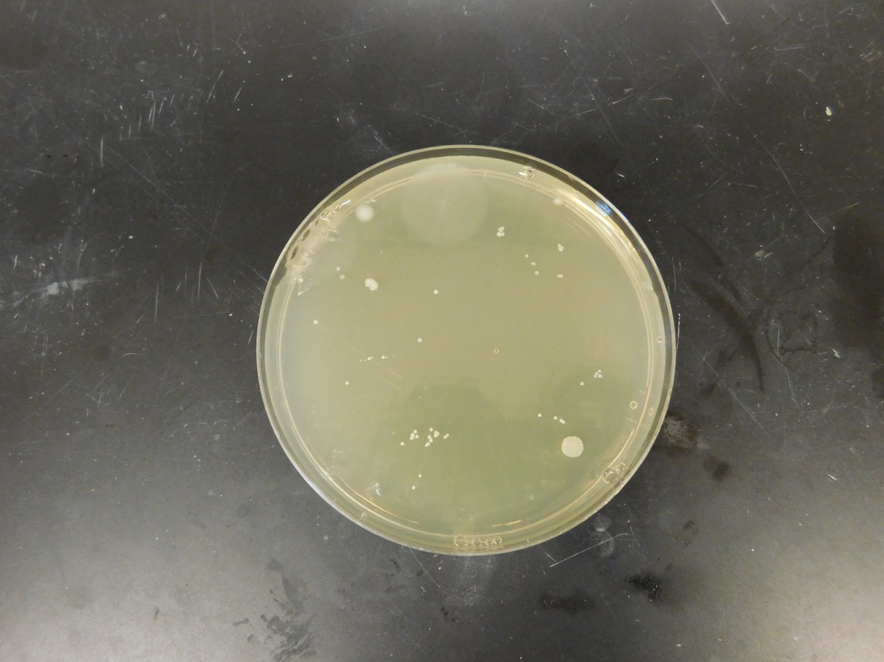
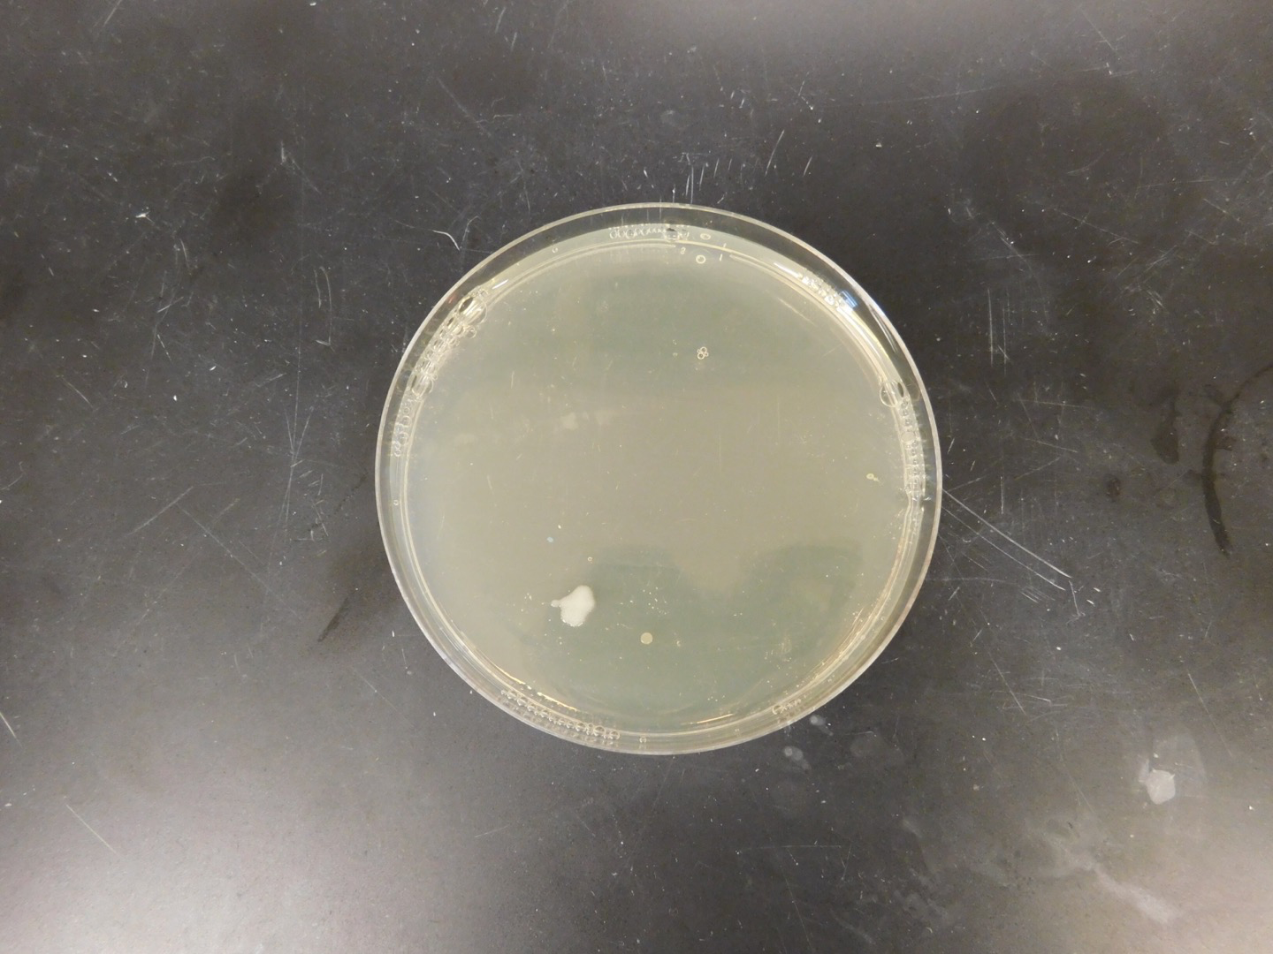
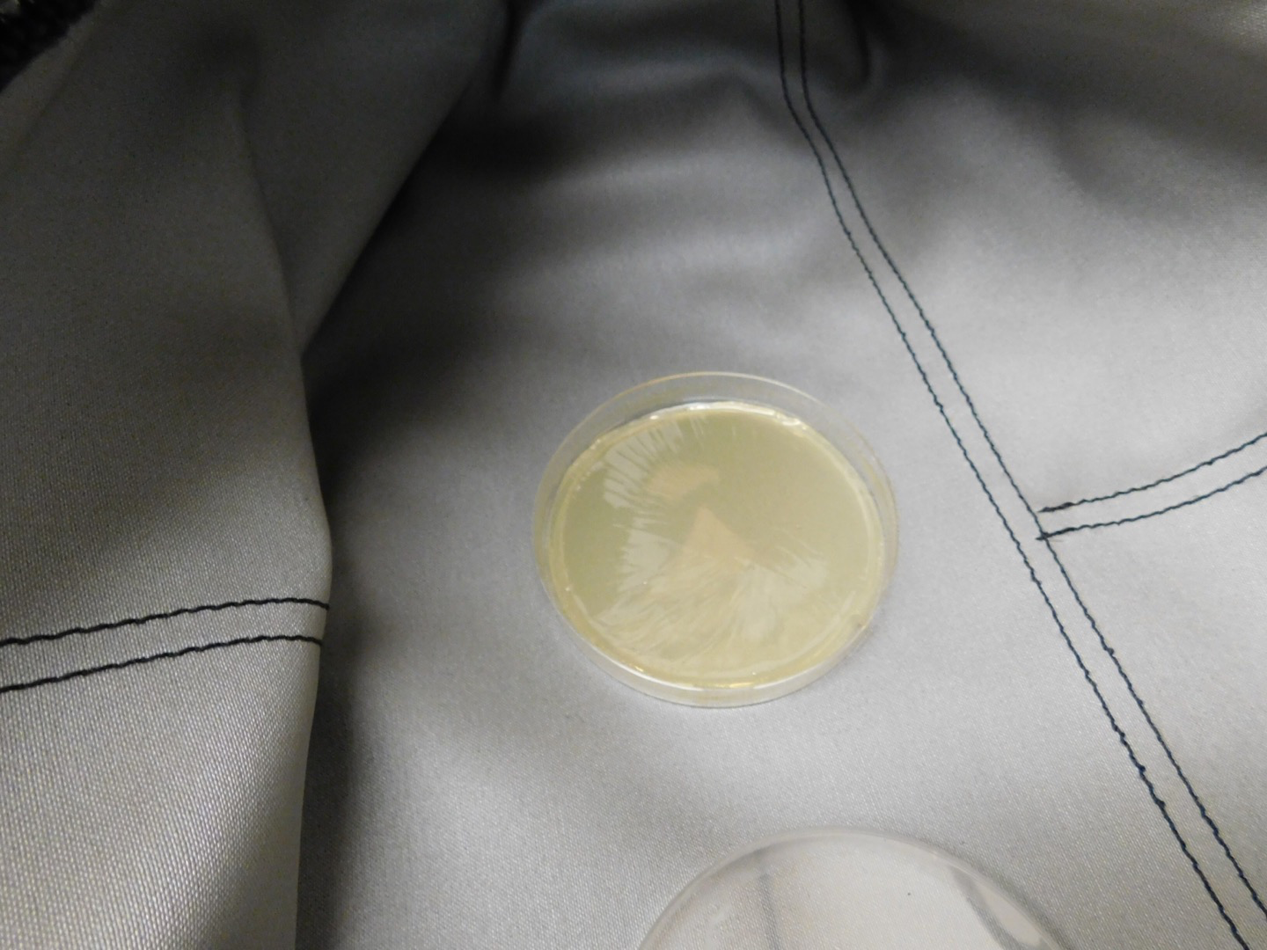
A.) B.) C.)

Figure 6. Day 3 of bacteria growth. A.) The petri dish left inside the cotton yoga bag; B.) The petri dish that was swabbed inside the cotton bag; C.) The petri dish that was swabbed outside the cotton yoga bag.
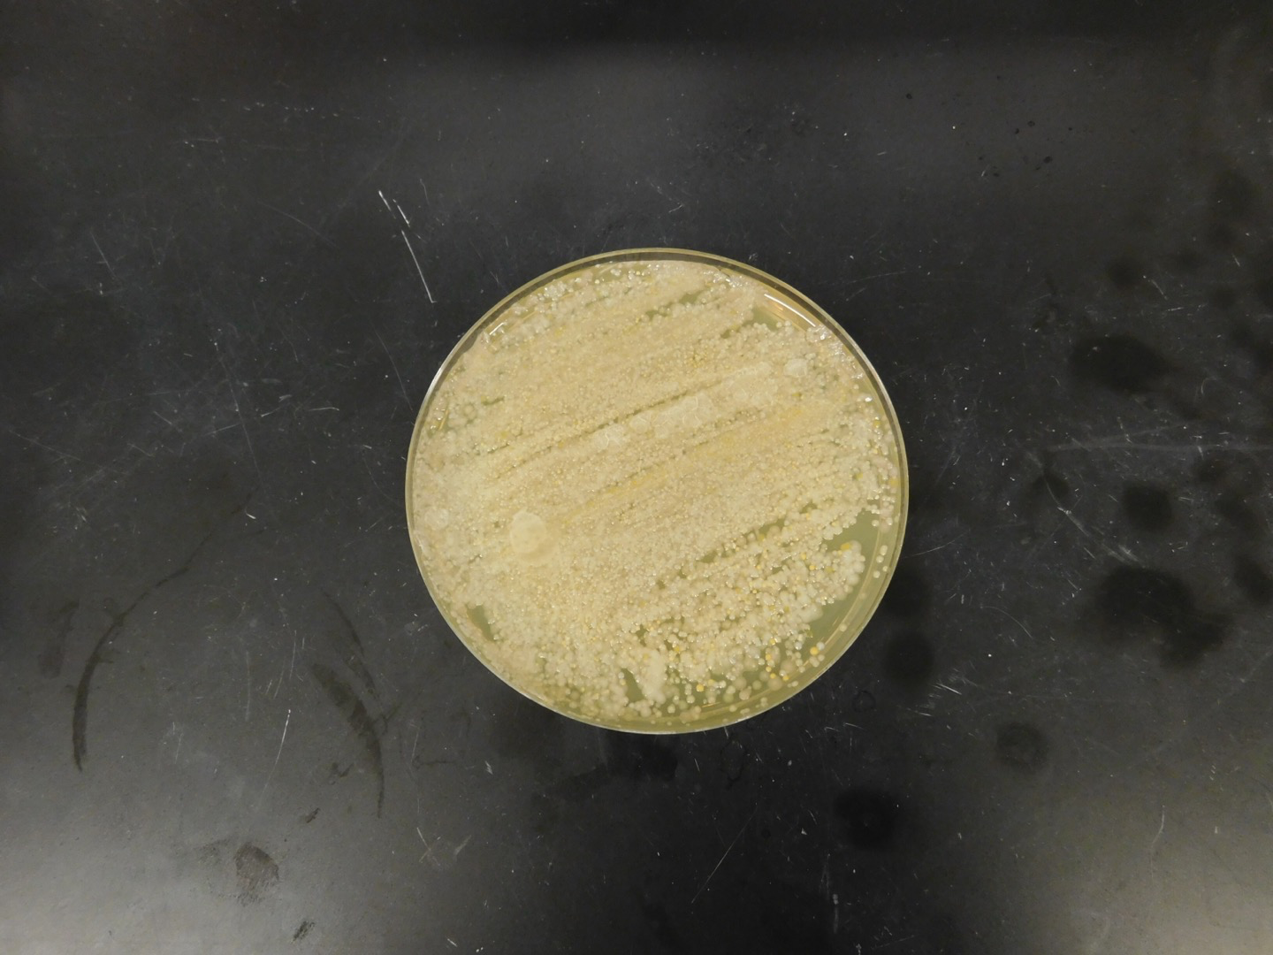
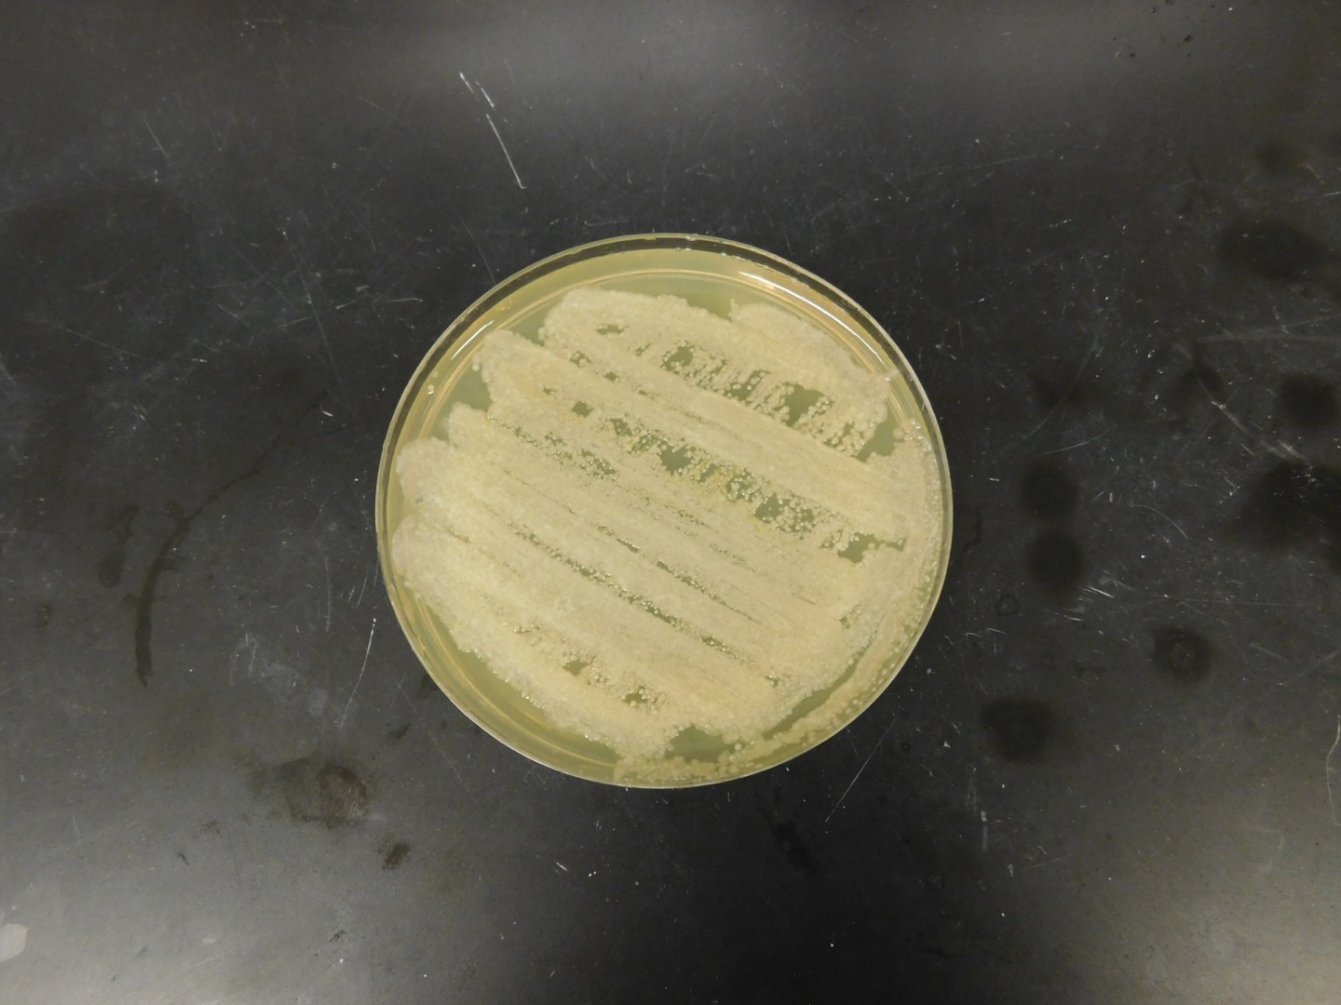
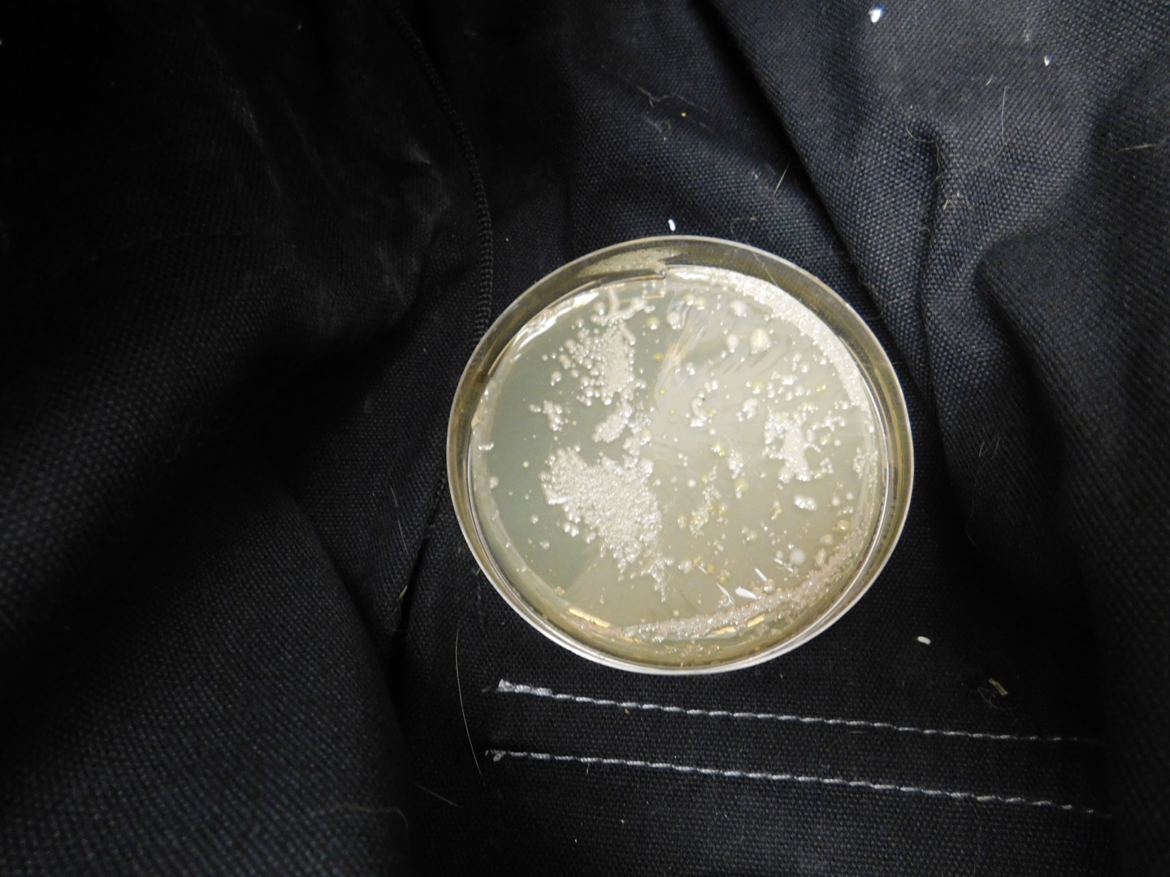
A.) B.) C.)

Figure 7. Day 3 of bacteria growth. A.) The petri dish left inside TPB; B.) The petri dish that was swabbed inside TPB; C.) The petri dish that was swabbed outside of TPB.
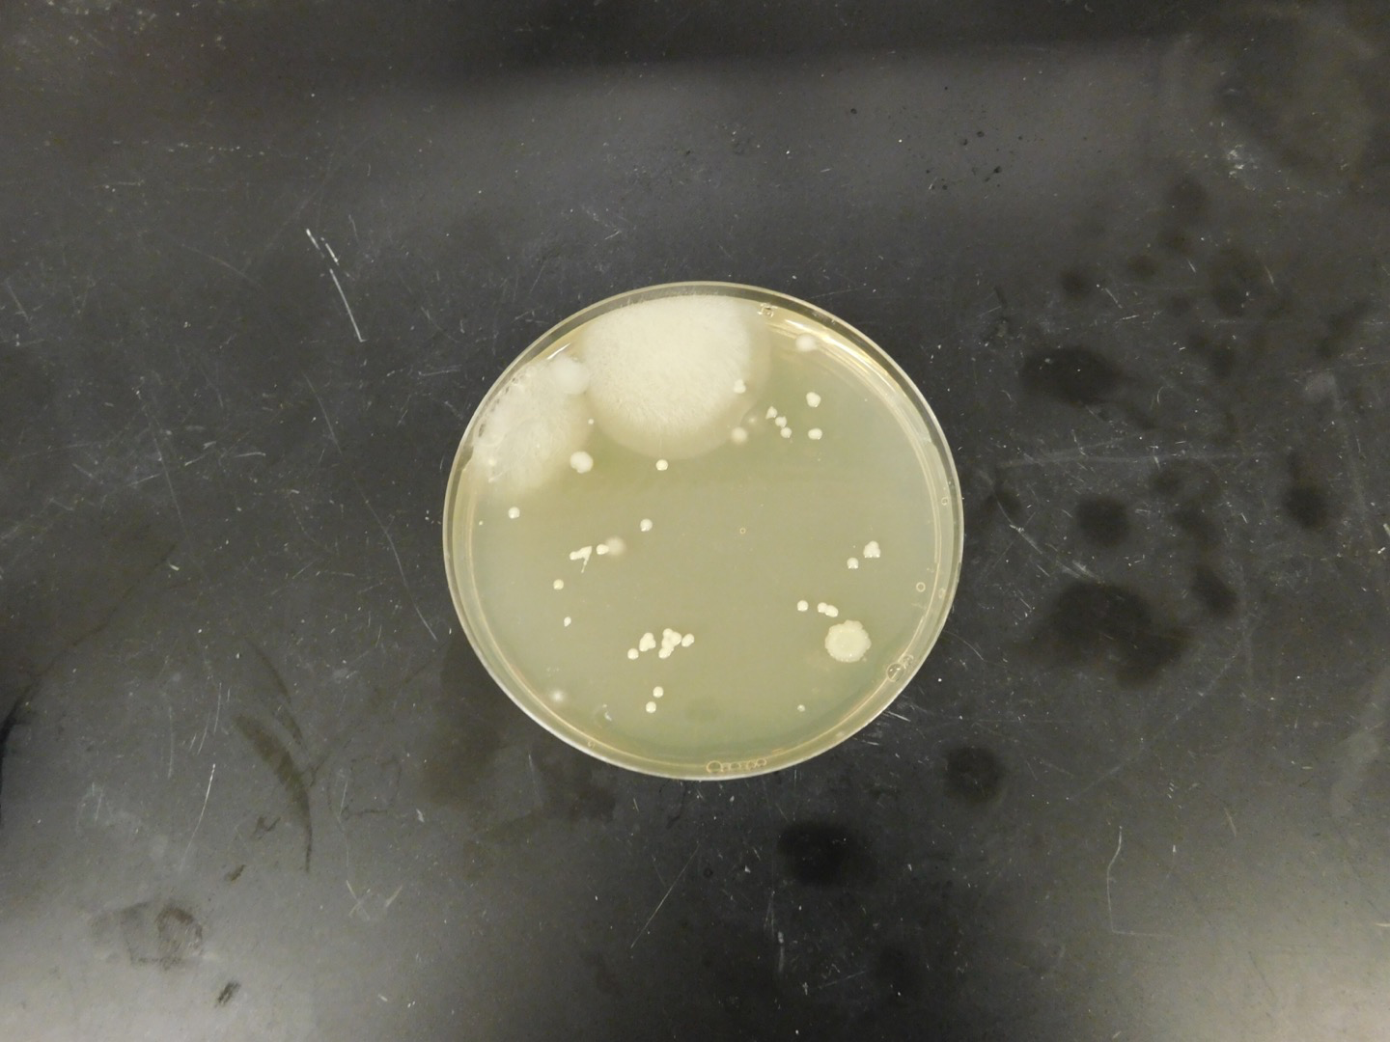
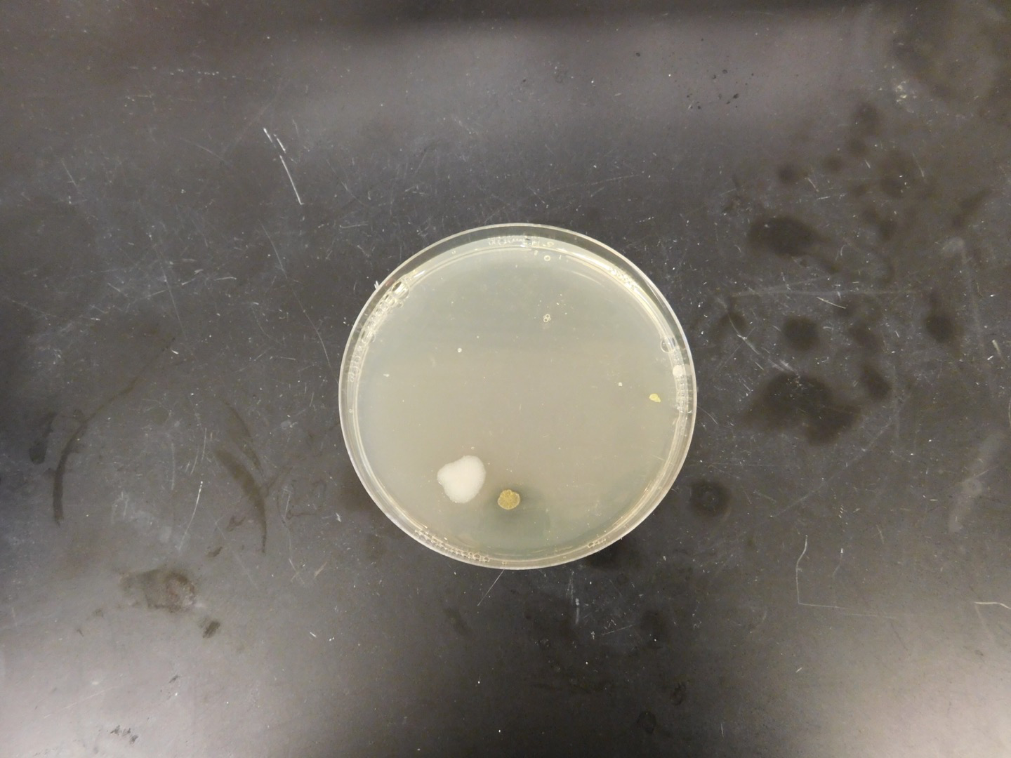
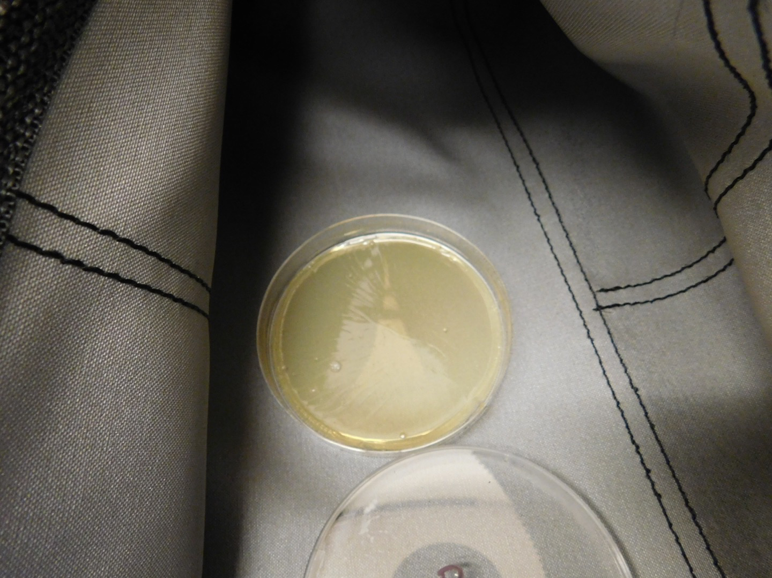
A.) B.) C.)

CONCLUSIONS – ThePureBag™ yoga bag data and study results indicated no discernable bacteria or bacterial colony growth during the three day study. The cotton yoga bag, however, showed evidence of visible bacteria colonies at the Day 1, Day 2 and Day 3 observations. These data support use of ThePureBag™ yoga bag instead of a cotton yoga bag to mitigate the presence and growth of bacteria on the both the inside and the outside surfaces of the bag.

